**RMS APPLICATION DEBUG AND REQUIREMENTS**

1. **Physical Verification**
2. 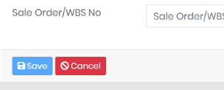Duplicate serial numbers should not be accepted only at same Receipt IDs and can be accepted at different Receipts(Completed).
3. Save button disabled / enabled colour not differentiable.

Difference should be clearly visible to user. (Completed).

1. “Relay Received With” portion: All radio buttons and check boxes should not have checked state at default conditions. Should be blank initially.(Completed)
2. Only closed Physical verification RIDs should go to RMA.(All PV should be entered from the box, then it goes to RMA Stage)(Completed)
3. Rack IDS to be entered before moving to repair stage.(Don’t show any RID until Rack id entered in RMS) (Completed)
4. Popup balloon notification on W/ CH declaration completion.(Any notification method)
5. **RMA** 
   1. 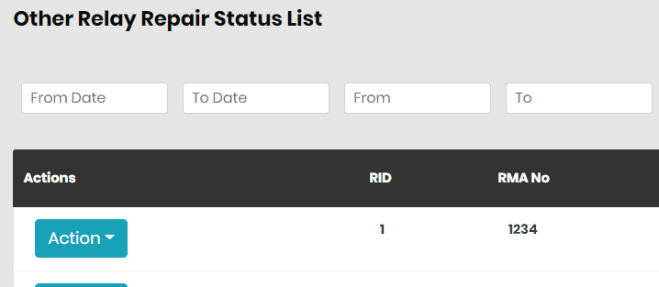On RMA completion, All category other than “SMP” and “OMU” should move to “Other Relay Repair Status” instead of “W/Ch Declaration” (Completed)
6. **CRC Dashboard:** All tables should have similar font and sizes (similar headings, similar content) and

total relays count in each table(Completed)

1. **Repair Priority**
   1. Entry: All waiting for repair should appear in table based on priority (open Job ticket) (Completed)
   2. Exit: Once repair started (started or completed job ticket) (Completed)
   3. Only SMP and OMU category should appear in table(Completed)
2. **Test**
   1. Entry: All waiting for test should appear in table based on priority (open test) (Completed)
   2. Exit: only on Aging completed (from test start to Aging complete) (Completed)
   3. 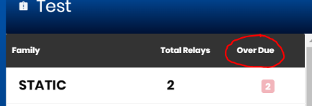Only SMP and OMU category should appear in table(Completed)
   4. Heading to be changed to “Test and Aging” (Completed)
   5. “Overdue” to “Overdue Relays” (Completed)

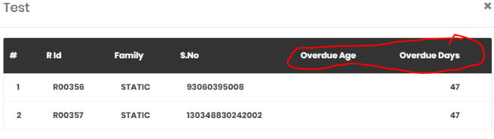

* 1. “Overdue Age” to “Stage Overdue Days”

Content: Current stage overdue days(Completed)

* 1. “Overdue Days” to “Overall Overdue Days”

Content: working days from physical verification to today – sum of till stage overdue Age(Completed)

1. **Dispatch**
   1. Entry: All Dispatch Approval (Waiting for Approval) (Completed)
   2. Exit: Dispatch completed (from Waiting for Approval to Dispatch complete) (Completed)
   3. All category should appear in table(Completed)
2. **Physical Verification**
   1. Entry: All Physical verification open receipts (open Receipts) (Completed)
   2. Exit: All Physical verification closed receipts (from open to closed Receipts) (Completed)
   3. 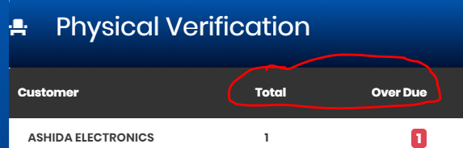No click function required. (Completed)
   4. “Total” to be changed to “Boxes Qty” (Completed)
   5. “Over Due” to be changed to “Overdue Days” (Completed)
   6. Only no of boxes and overdue days required(Completed)
   7. All category should appear in table(Completed)

1. **W/Ch. Declaration**
   1. Entry: All Waiting for Manager Approval(Completed)
   2. 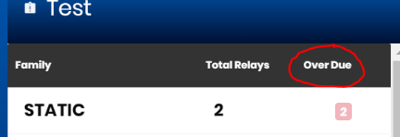Exit: All Manager Approval completion or waiting for customer approval (Completed)
   3. “Overdue” to “Overdue Relays” (Completed)



* 1. “Overdue Age” to “Stage Overdue Days”

Content: Current stage overdue days(Completed)

* 1. “Overdue Days” to “Overall Overdue Days”

Content: working days from physical verification to today – sum of till stage overdue Age(Completed)

1. **Customer Priority**
   1. Entry: All relays starting Physical verification(Completed)
   2. Exit: Till dispatch (Completed)
   3. All category relays should appear in this table(Completed)
   4. No click function is required in this table(Completed)
   5. Contents: Family, S.No, Stage Overdue Days, Overall Overdue Days(Can change font size)
2. **Receipt**
   1. Entry: All receipts (open Receipts) (Completed)
   2. 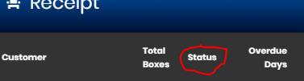Exit: when Physical verification starts (from open to started Receipts) (Completed)
   3. No click function required. (Completed)
   4. No “status” required (Completed)
3. **Repair**
   1. Entry: All open repair (Open Job ticket) (Completed)
   2. Exit: All repair completed (Completed Job ticket) (Completed)
   3. “Overdue” to “Overdue Relays” (Completed)



* 1. “Overdue Age” to “Stage Overdue Days” (Completed)

Content: Current stage overdue days(Completed)

* 1. “Overdue Days” to “Overall Overdue Days” (Completed)

Content: working days from physical verification to today – sum of till stage overdue Age

1. **Dispatch Report:**
   1. Search criteria should include Serial, category, customer.
   2. Search data to be displayed in table below like Repair report.
2. **Repair Report:**
   1. Search criteria should include Category, W/CH declaration, dispatch (Yes/no)
   2. W/Ch Serach dropdown, w/ch field change to text, customer setting extraction field, customer setting field,Add Dispatch field.
3. **Daily Report:** All tables should have similar font and sizes (similar headings, similar content) and

total relays count at bottom. All tables to be emailed daily.

1. **Received Relays**
   1. Should display all family relays received for day(Completed)
   2. Cumulative count should be displayed for current month(Completed)
   3. Should have total at the bottom like “Total Relays Completed” (Completed)

1. **Total Chargeable**
   1. Heading to be changed from “Total Chargeable” to “Total Chargeable Relays” (Completed)
2. **Warranty Overdue**
   1. Should display only SMP and OMU (No BOJ) (Completed)
3. **Total Completed**
   1. Reason spelling mistake(Completed)
4. **Repair Lead Time**
   1. Leadtime only for Product Type Numerical, Conventional, Multilin, Reason
   2. Leadtime calculations are only for Warranty of above types.
   3. Lead time calculations are average of current month relays.
   4. W/Ch based on SMP.
5. **Total Relay Completed**
   1. This month data alone. (Completed)
   2. Show current month next to heading with in bracket.
6. **Other Relay Repair Status**
   1. Provisions (screen) to enter Mgr comments at every actions (Completed)
   2. Actions lists are(Completed)
      * + 1. “Intimated to Procurement”
          2. “To be reworked by Supplier – In house”
          3. “Send to supplier”
          4. “Return to customer”
   3. On above conditions of “(c)” and “(d)”, send to dispatch approval and continue till dispatch. (Completed)
   4. Remove from the list once actions penetrating to “(d)” (Completed)
   5. Ensure every activity saved in query report(Completed)